|  |  |
| --- | --- |
| TANGUB CITY GLOBAL COLLEGE  J. Luna St., Maloro, Tangub City, Misamis Occidental    **INSTITUTE OF COMPUTER STUDIES**  **1st Semester, Academic Year 2024-2025** | |
| Student ID No.: 214527 | Name: Joevie P. Duhaylungsod |
| Schedule: 12:00 – 1:00 (MW) | Date: 26/11/2024 Score: |

**WEBINAR SUMMARY REPORT**

**Webinar 5: JPCS ITalks: AI and Cybersecurity**

**Date: September 14, 2024**

**Executive Summary**

The webinar “JPCS ITalks: AI and Cybersecurity" webinar, held on September 14, 2024, at the Divine Word College of Calapan, brought together aspiring IT professionals and experts to discuss the intersection of artificial intelligence and cybersecurity. Organized by the Junior Philippine Computer Society (JPCS) Calapan Chapter, the event aimed to enlighten participants on the growing challenges and opportunities in leveraging AI to strengthen cybersecurity frameworks.

**Discussion**

Dr. Ryndel V. Amorado highlighted how AI enhances cybersecurity by detecting threats, predicting vulnerabilities, and automating responses while addressing its dual potential for both protection and misuse. The session also explored real-world applications and ethical considerations, with participants actively engaging, reflecting their enthusiasm and growing awareness of cybersecurity's evolving role in the digital era.

**Concluding Remarks**

The webinar successfully equipped attendees with a foundational understanding of how AI and cybersecurity intersect. It emphasized the importance of staying updated with technological advancements while addressing ethical responsibilities. The event not only inspired participants to explore careers in these fields but also reinforced the critical role of continuous learning and innovation in safeguarding digital environments.

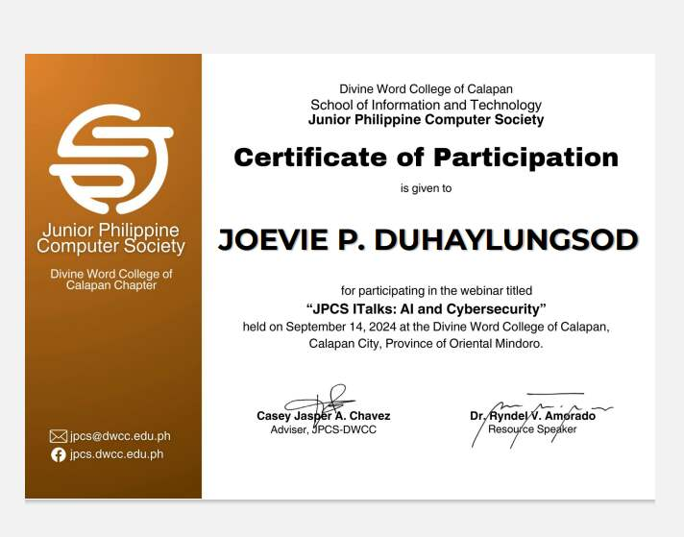**CERTIFICATION:**

**REGISTRATION:**

**ATTENDANCE AND EVALUATION:**

